Python

**String Manipulation**

Class viii

Lab 20

**Lab Objectives:**

* Value accessing
* Formatting
* Join, count, length, replace

Previously we known, the value which is inside the single quote or double quote is called String. String can be declared in two ways in python. That is using single quote or double quote. Both have merits and demerits.

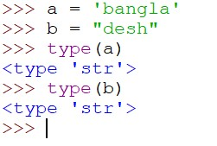

We have seen the example of two type of String. But there are some problems regarding single quote string. If we want to add quote for a specific word in any sentence, let’s see what happened.



The problem raised because when python gets first single quote it waits for the next one. After getting next one it thinks string is finished. But when python gets the third single quote it shows syntax error. So to get rid from this we can define string using double quote and if we want to specify any word we can use single quote inside the double quoted string.

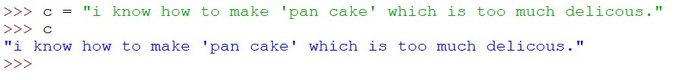

Boom! it’s solved.

**Index of String**

When we assign a string into a variable it follows some steps. Like

*>>> a = “Bangladesh”*

Every variable has index to store string into it. Index is like a

Multi-storey building. Which starts from ground floor then 1st floor, 2nd floor etc. Every variable has the same number type like building.



It has index which is also started from number 0 then 1,2,3,4,5 and so on. Here a *= “Bangladesh”,* the index number of B = 0, a = 1, n = 2, g = 3…………… so on.

*>>> a = “Bangladesh”*

|  |  |  |  |  |  |  |  |  |  |
| --- | --- | --- | --- | --- | --- | --- | --- | --- | --- |
| 0 | 1 | 2 | 3 | 4 | 5 | 6 | 7 | 8 | 9 |

Variable

Index

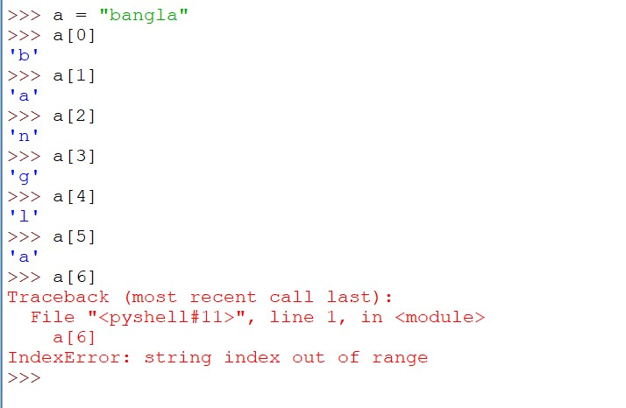Now check index using python IDLE. We will use *>>> variable[index no]* for checking.

Though word ‘Bangla’ has 6 fonts but we start from zero as index so we have got an error when we are trying to check sixth index of variable a.

String Formatting

We have learned about print () function by which we can print anything easily. Now we will assign a string ‘Bangla’ in variable ‘a’.

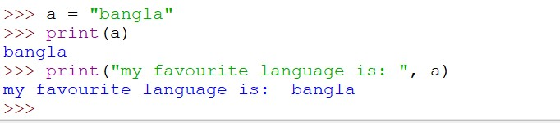we are using string and variable together in print function. Isn’t it interesting?

String Joining

Now we’ll play with string. For this take two variables a, b and assign ‘Bangla’, ‘desh’ into it than join it together and make Bangladesh.

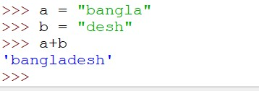

Now we will take three variables Dhaka, Khulna, Sylhet and join it. But the condition is we have to join it using hyphen like ‘Dhaka-Khulna-Sylhet’.

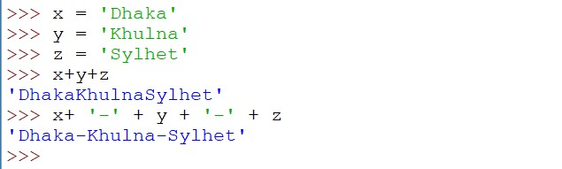

Is it ok? We could have done this by more easiest way using join () function. Have a look.

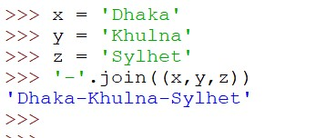

Upper Case and Lower Case

The value of a is bangla. Here the first letter of bangla is b which is a small letter. We will make it capital letter using capitalize () function.

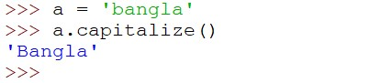

If we want to turn every character into capital letter we have to use upper () function.

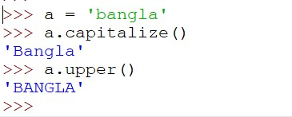

If we want to turn every first character of a word into capital letter we can easily use title () function.

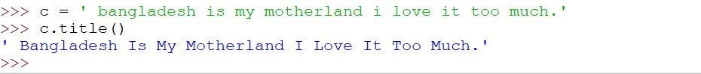

Aren’t you feeling too much fun?

You can also turn capital letter into small letter. Just use lower () function.

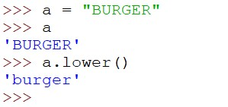

You can check the length of a string. Use len () function.

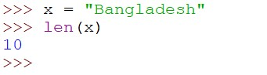

A character can be replaced by another character using replace () function.

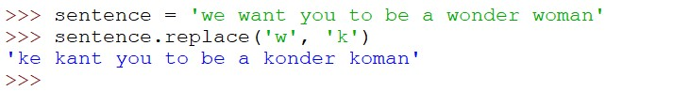

You can count a character that how much it is used in string. Just use count () character.

